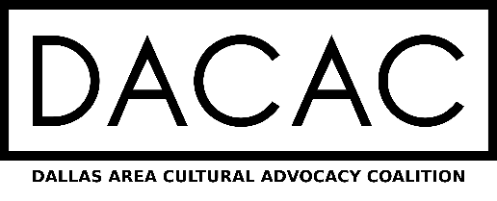

ARTS & CULTURE QUESTIONNAIRE
2021 DALLAS CITY COUNCIL CANDIDATES

Thank you being a candidate and for your willingness to serve! And thank you in advance for answering the DACAC Arts & Culture Questionnaire for candidates for Dallas City Council in the upcoming 2021 election. You can fill this out online at this LINK. The responses can go below, and the form saved as a pdf and emailed to dacac@artsdallas.org.

- NAME:

- COUNCIL DISTRICT:

- YOU AND THE ARTS
Give us a sense about your relationship with the arts
(Some ideas to consider)
- What art form or cultural organization do you particularly enjoy?
- Are your family members involved in the arts?
- Share favorite cultural experience in the last two years?
- What virtual arts programs have you and your family enjoyed during the pandemic?

- ADVOCACY
The support of our elected City leaders is important to ensuring arts and culture remain a priority at City Hall and part of the civic dialogue.
QUESTION: How have you advocated for the arts community and/or how will you do that going forward?

- SUPPORT & RECOVERY
Prior to COVID, the Dallas creative economy was on track to have an economic impact surpassing $1B a year, a vital business sector. The pandemic derailed that momentum. Arts facilities were the first to close and will be among the last to reopen at full capacity. The city’s nonprofit arts and cultural community has lost more than $95M and over 1,000 jobs and cultural tourism has virtually stopped. City support has been critical to keeping these institutions alive. Even in a tough budget year, this need remains.
QUESTION: Will you work to see that City support continues and how will you ensure arts and culture play a key role in the Dallas economic recovery?

- EQUITY AND NEIGHBORHOODS
The top pillar of the Dallas Cultural Plan is Equity, with a goal of ensuring arts and culture are accessible in communities that have been historically underserved. And we know when arts are purposefully imbedded in the community, they can fight urban blight and create vibrant neighborhoods.
QUESTION: How will you keep the focus on equitable access to the arts; and specifically, where, and how would you like to see art used to address challenges in your City Council District.
(Some applications to consider)
- Murals
- Underpass transformation
- More opportunities for ALAANA artists in underserved communities
- Popup cultural centers
- Neighborhood performances
- Economic incentives for developers to create affordable galleries, workshop spaces and artists housing

- PARTICIPATION
The Dallas arts and cultural community is diverse and growing and contains a range of genres, ethnicities, locations and more. Every group, especially those serving your district, is honored when elected officials attend a program, visit our organizations, or even stop by a monthly DACAC meeting to say hello.
QUESTION: Will you commit to attending local programs (performances, exhibitions, classes) or meeting with a Dallas arts organization on a regular basis? What would that look like?

While DACAC does not endorse candidates, these responses do guide consideration for support by individuals such as arts patrons and advocates, artists, board members, and more. Your responses will be publicly shared on our website to review. www.DallasNeedstheArts.com.

