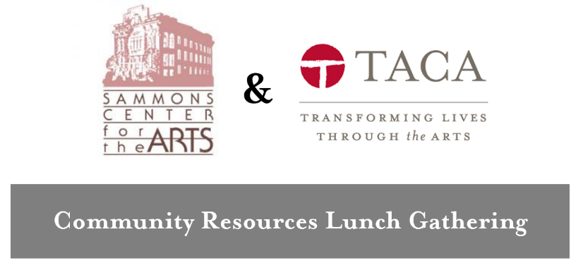
Latino Cultural Center
Friday, June 16, 2017

Better Together Grants
A pilot grant opportunity from The Lyda Hill Foundation, The Dallas Foundation, Meadows Foundation and the United Way of Metropolitan Dallas that seeks to encourage formal, long-term collaboration between nonprofits
https://www.bettertogetherfund.org/

Board Source
Information on nonprofit governance and boards
https://boardsource.org/

The Bridgespan Group
Helps nonprofit Groups and Funders create better partnerships
https://www.bridgespan.org/

North Texas Business Council for the Arts
Leadership Arts Institute and search tools to find new board members with specific skills
http://ntbca.org/

Catchafire
Opportunities for free professional services
https://www.catchafire.org/

Center for Nonprofit Management - Opp501 Job Board
http://cnmconnect.org/jobs/

City of Dallas Office of Cultural Affairs
http://dallasculture.org/

Crowdster – Crowdfunding platform
http://crowdster.com/

Culture Track
http://culturetrack.com/

Dallas Arts & Cultural Advocacy Coalition (DACAC)
https://www.dallasneedsthearts.com/

Dallas Convention and Visitors Bureau
TPID Funds: http://www.dtpid.com/

Dallas Public Library Resources
Foundation Center (6th Floor)
Charity Navigator (6th Floor)
Seminars at the library
Fine Arts Department (displays for anniversaries, special events, etc.)
Conference rooms
Archiving resources

DataArts
http://culturaldata.org/

DISD – Visual and Performing Arts
The new head of the visual and performing arts, Tim Linley, is a resource for education programs
tilinley@dallasisd.org
http://www.dallasisd.org/Page/14039

Internships.com
Internship posting and search service
http://www.internships.com/

KERA Art&Seek
Calendar listing for arts events and opportunities for unique arts coverage
http://www.artandseek.org

Network for Good
Fundraising software and webinars
http://www.networkforgood.com/

North Texas Cultural Co-op + Data Center Digital
http://www.taca-arts.org/ntcc/

NTEN
Membership organization of nonprofit professionals who put technology to use for their causes
https://www.nten.org
https://www.nten.org/nonprofit-tech-clubs/dfw

Meadows Conference Center
http://www.mfi.org/mcc/

Sammons Center for the Arts
http://www.sammonsartcenter.org/

Social Impact Architects – Dallas-based consulting firm and nonprofit how-to blog, Social TrendSpotter
http://www.socialimpactarchitects.com
https://socialimpactarchitects.com/blog

Social Venture Partners Dallas
http://www.socialventurepartners.org/dallas

State Farm Good Neighbor Grant
Provides grants to nonprofits where employees volunteer. Liberty Mutual and Texas Instruments have similar programs.
https://www.statefarm.com/about-us/community/education-programs/grants-scholarships/company-grants

TACA
http://www.taca-arts.org/

Taproot Foundation
Similar to Catchafire (see above) but without membership requirements and free
https://www.taprootfoundation.org/

Texas Association of Nonprofit Organizations (TANO)
https://tano.org/

Texas Accountants and Lawyers for the Arts
http://talarts.org/

Texas C-Bar
http://www.texascbar.org/

Texas Commission on the Arts
http://www.arts.texas.gov/

TechSoup & TechSoup Stock
offers nonprofits a one-stop resource for technology needs by providing free information, resources, and support. Also, offer a product philanthropy service called TechSoup Stock. Here, nonprofits can access donated and discounted technology products, generously provided by corporate and nonprofit technology partners.
http://www.techsoup.org

University of Texas Dallas – EPICS (Engineering Projects in Community Service)
Engineering partnerships with nonprofits to help with data oriented projects
https://epics.utdallas.edu/

VOLY
Volunteer listings and awareness
https://www.voly.org/

WRR
http://www.wrr101.com/

